COLLABORATIVE MULTI-AGENT CODING STUDIO

I have six role-differentiated agents to implement in my research project:
- Coordinator Agent:
  - The coordinator agents will observe what the student is going through and help only when needed, and decide which agent to react
- Coding Agent
- Critic Agent
- Debugging Agent
- Planner Agent
- Motivator Agent
I essentially want to build an application that teaches by asking guiding questions instead of giving answers (using Socratic questioning and hints before giving full solutions), forcing students to think.
This will be student collaborations, also help them in career guidance by seeing their chat history, like recommending them and telling them how to achieve if they are interested, it will also have a personal chat just for individual assignments. This platform is human-in-the-loop, so AI will interrupt only when it is facing a problem with the assignment, either in the group or personally
This is how I intend to orchestrate the agentic flow: a boss agent reads the situation, delegates to worker agents, collects their output, and decides what the user sees. The workers don't talk to each other directly.
I intend to implement a CASM
CASM: Cognitive Affective Social Model
“What we currently believe about the student”
- Three parts: Semantic (Knowledge facts), Episodic (what happened), and Social (per-student profile: knowledge level, affect, talkativeness, misconceptions)
- It is inferred from the conversation, not measured directly
- It should keep updating its belief state.
I have to record every trace of AI interaction with the student. The complete recorded log of everything that happened, turn by turn; who said what, which agent reasoned, responded, what action it took, how confident it was, timestamps, and where the student corrected it.

MY IDEAS about the project:
- I WANT MY AI AGENTS TO ADAPT/ADJUST TO THE USER. i.e, CO-EVOLUTIONARY
  - the student also builds a model of the AI (its reasoning, confidence, blind spots) and corrects it, and the AI updates accordingly
  - Each side keeps an explicit model of the other. The agent models the student (that is CASM)
  - The agent exposes its own model (States its own reasoning, confidence, and the current belief about the student loud, instead of presenting answers as authoritative fact) so the student can see and challenge it: “I'm 60% confident, here's why.” Grounded in Bendell et al. (2025); team outcomes depend on how each party models the other <- MUTUAL MODELLING
  - The agent updates its belief about the student (the CASM profile) after a correction or an override. This is the co-evolutionary mechanism. It's just “write the new belief into the state object,” and it's central. <- AGENTIC SELF-IMPROVEMENT:
- Every bit of the model’s behaviour should be captured by a Trace Schema, So that the whole system can be an “AI-EXPLAINABLE”
- VERIFICATION-AWARE ENGAGEMENT: If a user hands the whole task or assignment to the AI and accepts the output without engaging, this is a delegation pattern and my system should importantly avoid this.
  - If a user hands the whole task, model should not allow it.
  - Even if model somehow allows it and outputs an answer, if the user does not engage with the AI, like asking follow up questions/ doubts, etc, the model should note the behaviour and relevant AI Agent should interrupt or join the conversation saying this is a bad behaviour and correct both the Agent and Student, Agent should learn from its mistake and evolve.
- Participation Equity: Whether contribution is spread fairly across team members vs dominated by one person. I intend to measure it with the Gini coefficient over turn counts, and Cohen’s k (kappa). If you have better alternatives, do suggest it. My Planner and Coordinator agents are meant to improve it by giving quiet members defined roles.

EVALUATION:
- ASTRA Simulated Benchmark:
  - ASTRA gives 540 simulated participants, 1,440 episodes
  - I have to tune prompts and thresholds on this fake data first, so no real student is exposed to a half-baked system
  - I plan to divide these participants into teams of 4-6 people, and each team will be given one condition only: either the CodeEdu baseline, or my full studio. And we compare the groups.
  - I plan to use “Linear mixed-effects model”, which is a statistical model for data that is nested (individuals inside teams inside conditions). Because I believe it is the correct tool when people aren’t dependent, but I’m open for alternatives if you have better one.
- Deployment study (Once the application is developed)
  - The actual student teams use the system
- Here are some statistical tests I intend on doing (I’m open for criticisms):
  - Holm–Bonferroni correction
  - Cohen's d / effect size
  - Power calculation
  - Reflexive thematic analysis (Braun & Clarke)
  - LLM-as-judge (maybe integrate this into one of my original agents?)
Just choose 2 best among these for my project for now.

AGENTIC ORCHESTRATION:
NOTE: These are the three things that should matter the most!! Evaluation pipeline, Observability (Tracing) setup, and the Failure-recovery logic.
These are the things that matter the most:
- Routing: which agent should handle this? (Critic? Motivator? nobody?). Essentially, one dispatcher inspects each message and sends it to exactly one agent, but I believe this is too rigid for my 6 agents that should sometimes act unprompted.
- Context: what does the chosen agent get to see? (full history? just the last message? the CASM state?)
- Arbitration: if two agents want to speak, who wins, and who stays quiet? (this is my Coordinator's job). My coordinator would be the boss agent that reads the situation, watches the trace. and delegates to worker agents, collects their output, decides what the user sees. The workers don't talk to each other directly.
- Sequencing: do agents run one after another, in parallel, or only when triggered? This is useful inside a single task step (e.g, critic always review after the code is written), but too rigid as the whole system
- Termination & recovery: when does a turn end, and what happens if an agent errors or loops forever?
- LangGraph’s Graph (State Machine): You draw an explicit graph: nodes are agents/tools, edges are conditions for moving between them. Supports loops, branches, and pausing for a human. This will give me audit trails. Checkpoints, HITL pause points, etc
This is the essential orchestration idea: Use a supervisor pattern implemented as a graph. Concretely: the Coordinator is the supervisor node; the Critic, Debugging, Planner, and Motivator are worker nodes; the shared CASM/trace state flows between them

Focus on the State, Memory, and Context Management.
- State: the live object passed between agents this session (the CASMState plus the message history). In a graph framework this is a single typed object every node reads and writes.
- Memory: what persists across sessions. Short-term memory is the current context; long-term memory is something you store and reload (a file, a database, or the trace itself).
- Context window: the hard limit on how much text the model can read at once. Six agents each pasting the full history quickly overflows it and runs up cost/latency. So you curate context: the Critic sees the code + recent turns; the Motivator sees affective signals + recent turns; nobody gets everything. Deciding this is itself an orchestration choice.

Tool Calling (MCP):
Critic and Debugging agents runs the student's code, runs a test, reads a file. They require tool calling.

Hallucination Control and Answer Faithfulness (My TOP PRIORITY):
Ensure (You can add more):
- Grounding: Always give the agent the actual code/test output and instruct it to answer only from that.
- Tool-verified claims: Don't let an agent say the tests pass. make it run them and report the real result. This is the single biggest win and it's exactly your Critic agent's job.
- Self-consistency / second opinion: Ask again (or ask a second agent) and see if answers agree; disagreement flags uncertainty.
- Confidence exposure: Have the agent state its confidence (“60%, here's my evidence”). My proposal already requires this; it doubles as a hallucination signal and as your “explainability.”
- LLM-as-judge faithfulness scoring: After the fact, score a sample of turns: “Does this agent's claim follow from the code it was shown?”
These are the tools that measure these (Select one best for my project):
Arize Phoenix (open-source, 50+ research-backed metrics incl. faithfulness and hallucination), RAGAS (the faithfulness/relevancy/context triad), Langfuse (open-source, MIT) for trace capture you can attach scores to.
“The Critic forces tool-verified claims; the trace records whether verification happened; a faithfulness metric (LLM-as-judge, validated against human labels) quantifies it.”

Human-in-the-loop: Ensure the system pause for a human at chosen points instead of barelling ahead.
- Approval gates: the agent proposes, the human confirms before anything happens (e.g. the Planner proposes an allocation; a student can override). Overrides update the model rather than being ignored; that's the co-evolutionary loop.
- Correction events: the human contradicts the agent's stated belief, and that correction is logged as a first-class trace event. This is the literal mechanism of your contribution.
- Escalation / opt-in: the human can summon an agent (your “practitioners can invoke the Motivator explicitly”) or dismiss one.
If you recommend anything else, I’m open for it.

Ensure Traceability, observability, explainability, audit trails <- TRACE SCHEMA

Implement SAFETY GUARDRAILS
- Input guardrails: block prompt-injection and off-task requests before they reach an agent.
- Output guardrails: filter toxic, unsafe, or off-policy responses before the user sees them (e.g. the OpenAI Moderation API for toxicity).
- Behavioural guardrails: rules the orchestration enforces, e.g. the Critic must never just give the answer; the Motivator must never give content help; only one agent speaks per turn.
Motivator is the highest-risk component in the whole system because inferring emotion from text can misread productive frustration as distress. These re the guardrails I specified in my proposal:
- Conservative thresholds (act only on strong, sustained signal).
- Question-framing (“You might be stuck, or in flow?”) so a wrong inference is harmless and correctable.
- A validated calibration set (κ ≥ 0.7) with reported false-positive rates.
- Never exposing affective inferences to supervisors/markers

SANDBOXING should be done with Python for now.

I want you build this project as a web-application for me

This is how my web application interface should look like 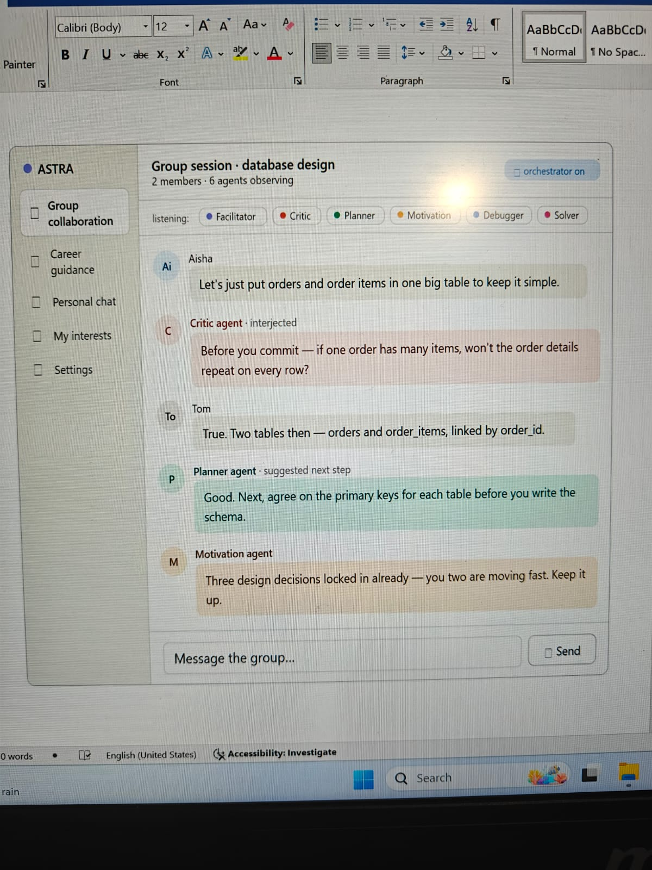
Don’t have to implement the Career Guidance , My Interests, and Settings pages for now. Main focus should be Group Collaboration, and then Personal Chat.

